Homework 5

David Zhao

CSCE 1040

Design Doc

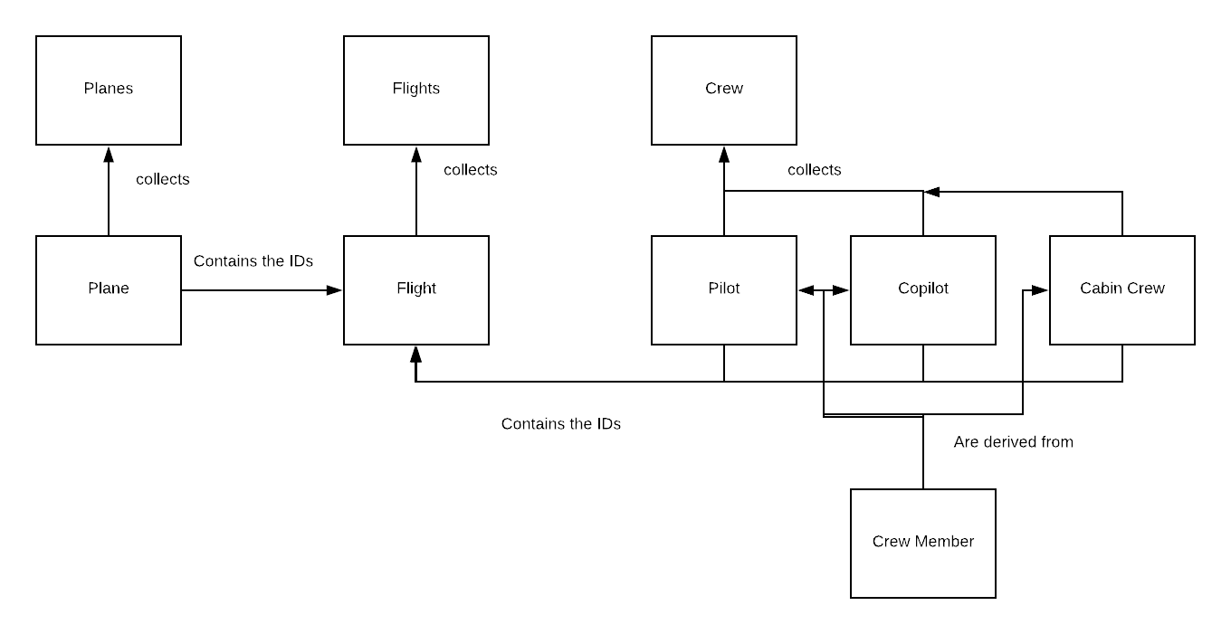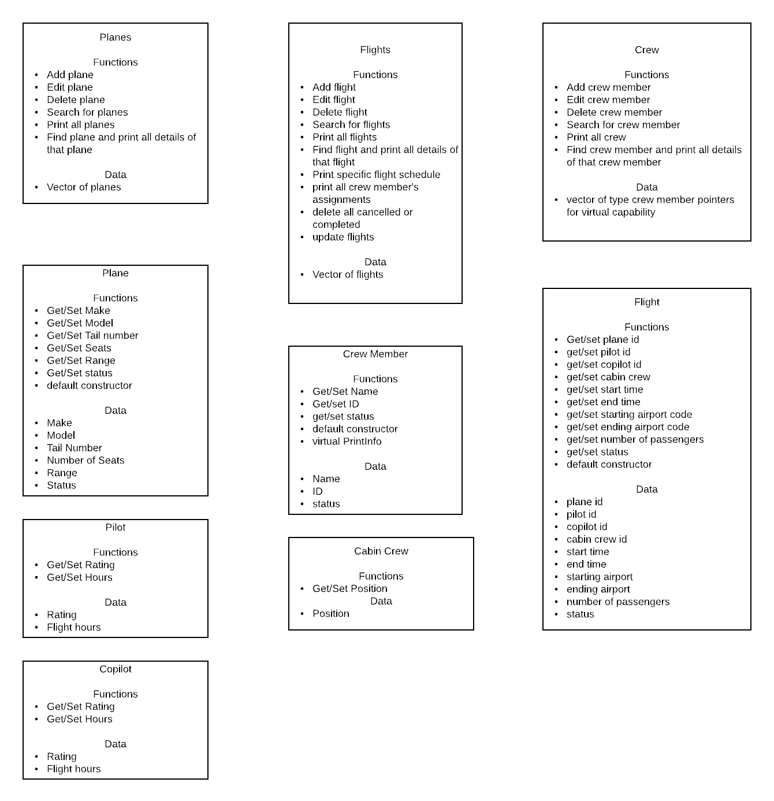

**Plane:**

String make, tailNum, status

Int model, seatsNum, range

Accessors and mutators for all of the above data

Default constructor sets all strings to “ “ and all integers to 0

**Planes:**

Vector <plane> planeList

Int searchPlane(string planeNum)

iterates through the vector until it finds the plane that returns planeNum with getPlane(), then returns the iterating counter in the for loop

if plane is not found, returns -1

bool addPlane(plane newPlane)

use searchPlane with the given newPlane to see if any planes match. If not,

push_back newPlane to vector of planes and return true and store data (storing data happens in menu function)

else return false

bool editPlane(plane edited)

call searchPlane using the plane number from edited, then use that as planeList[iterator] to find the plane

if plane not found, then return false

then check to see if get functions return default values from edited; if so, don’t replace for that value. If functions return non-default values, use set functions on planeList[iterator]. Then return true and store data

bool deletePlane(string planeNum)

call searchPlane using planeNum

if searchPlane returns -1, return false

else, planeList.erase(planeList.begin() + number from searchPlane – 1) and store data

void printPlanes()

iterates through the vector (probably with .at() and a for loop) and prints out the get function for each one

bool printEntry(string planeID)

uses searchPlane(planeID) to find the plane, returns false if plane not found

if plane found, print out all the accessors and return true

**Crew Member:**

String name, status

Int id (or long, depends on how long expected ids are)

Accessors and mutators for all of the above

Default constructor sets strings to “ “ and int/float to 0

**Pilot:**

String rating

Int hours

Accessors and mutators for the two

Default constructor

**Copilot:**

String rating

Int hours

Accessors and mutators for the two

Default constructor

**Cabin Crew:**

String position

Accessor and mutator

Default constructor

**Crew:**

Vector <crewmember*> crewList

Int searchCrew(int/long crewID)

iterates through the vector until it finds the crew member that returns crewID with getCrew(), then returns the iterating counter in the for loop

if plane is not found, returns -1

bool addCrew(crewmember newCrew)

use searchCrew with the given newCrew to see if any crew match (probably just gonna use getID and use that). If not,

push_back newCrew to vector of crew members and return true and store data

else return false

bool editCrew(crew edited)

call searchCrew using the crew ID from edited, then use that as crewList[iterator] to find the crew member

if crew member not found, then return false

then check to see if get functions return default values from edited; if so, don’t replace for that value. If functions return non-default values, use set functions on crewList[iterator]. Then return true and store data

bool deleteCrew(int/long crewID)

call searchCrew using crewID

if searchCrew returns -1, return false

else, crewList.erase(crewList.begin() + number from searchFlights – 1 (not sure if -1 is necessary, clarify later)) and store data

void printCrew()

iterates through the vector (probably with .at() and a for loop) and prints out the get function for each one

bool printEntry(int/long crewID)

uses searchCrew(crewID) to find the crew member, returns false if crew member not found

if crew member found, print out all the accessors and return true

**Flight:**

String planeID, startPort, endPort, status, startTime, endTime (start time and end time are

strings entered by user. Only converted to time when actually needed to compare.)

Int pilotID, copilotID, cabin1, cabin2, cabin3, numPass, flightID

Accessors and mutators for all of the above

Default constructor sets strings to “ “ and ints to 0

**Flights:**

Vector <flight> flightList

Int searchFlights(int/long flightID)

iterates through the vector until it finds the flight that returns the flightID with getFlightID(), then returns the iterating counter in the for loop

if plane is not found, returns -1

void addFlight (flight newFlight) (function that returns int so that I can clarify which thing went wrong)

first, use updateFlights() to make sure all planes that are inactive are set to inactive. (addendum: placing most of this stuff within the main function so that I can search the other vectors) Then, use searchflight with the given newFlight to see if any flights match (probably just gonna use getID and use that) IDs, if the plane is busy, if the passengers of newFlight are less than the plane’s seats, and that the crew is not already assigned. Also check to see if the crew members are in valid positions. If not,

push_back newFlight to vector of flights and return true and store data

epiphany for later: use difftime to check differences between start and end time of all flights and new flight, then vice versa, then start and start, and end and end

make vector of integers to save indices, loop through list of flights and mark down any and all indices where there’s an overlap in crew or plane, then plug those indices into checking the times and difftime thing

bool editFlight(flight edited)

call searchFlight using the flight ID from edited, then use that as flightList[iterator] to find the flight

if flight not found, then return false

then check to see if get functions return default values from edited; if so, don’t replace for that value. If functions return non-default values, use set functions on flightList[iterator]. Then return true and store data

bool deleteFlight(int flightID)

call searchFlights using flightID

if searchFlight returns -1, return false

else, flightList.erase(flightList.begin() + number from searchFlights – 1 (not sure if -1 is necessary, clarify later)) and store data

void printFlights()

iterates through the vector (probably with .at() and a for loop) and prints out the get function for each one

bool printEntry(int flightID)

uses searchFlights(flightID) to find the flight, returns false if flight not found

if flight found, print out all the accessors and return true

int printFlightsAssignment(string planeID)

has integer check for checking how many assignments were printed

loop through vector and find all flights with planeID as the plane id

if those flights are active, print those flights’ start and end times, iterate check

return check at end

int printCrewAssignment(int/long crewID)

has integer check

loop through vector and find all flights with crewID as one of the crew members’ id

if those flights are active, print those flights’ start and end times, iterate check

return check

int printFlightStatus(string compareStatus)

has integer check

loop through vector and find all flights with status == compareStatus

print out flightIDs, iterate check

return check

int deleteFlightStatus(string conStatus)

has integer check

loop through vector and find all flights with status == conStatus

delete those with erase(flightList.begin() + iterator - 1), restart iterator, check++

return check

void updateFlights()

check current time

loop through flightsList to check if any of their end times are before current time

if so, update those statuses

void storeFlights()

prints out the size of the vector

use printentry on every single thing in the vector into an output stream

void loadflights()

uses getlines and cins on an input stream, plugs those values into a flight, then uses .push_back on that flight

**Menu:**

Options: Add a crew member, add a plane, add a flight, delete a crew member, delete a plane, delete a flight, edit a crew member, edit a plane, edit a flight, find a crew member, find a plane, find a flight, print all crew members, print all planes, print all flights, print all details of a crew member, print all details of a plane, print all details of a flight, print assignment schedule for a flight, print assignment schedule for a crew member, print flights from status, delete cancelled flights, delete removed flights, update flights

Each of the above is just a combination of the methods and functions of the classes

**Loading and Storing:**

For storing data:

Use the functions for each collection class

For loading data:

Use the functions for each collection class